The e-portfolio learning cycle

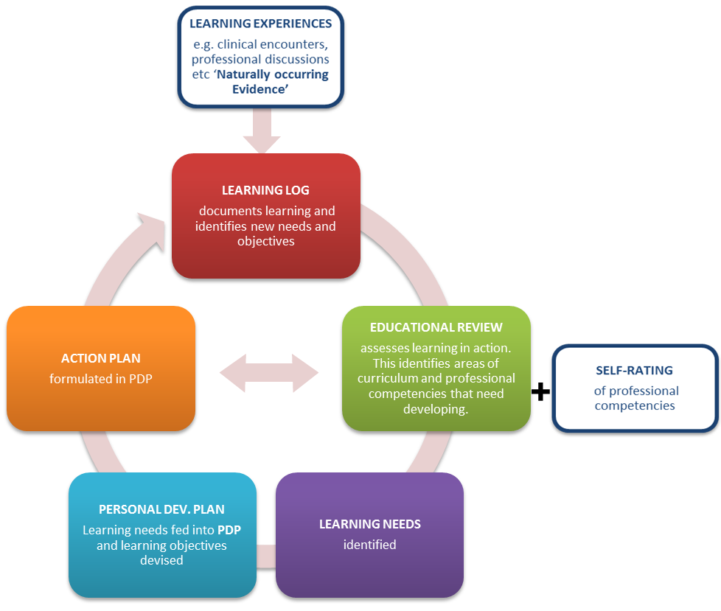
(Reproduced by kind permission of Drs. David Palmer and Charlotte Hart)

This diagram illustrates one of the numerous little learning cycles that should be happening at practice (workplace) level.

